1. Install nginx and run nginx on port number 81.

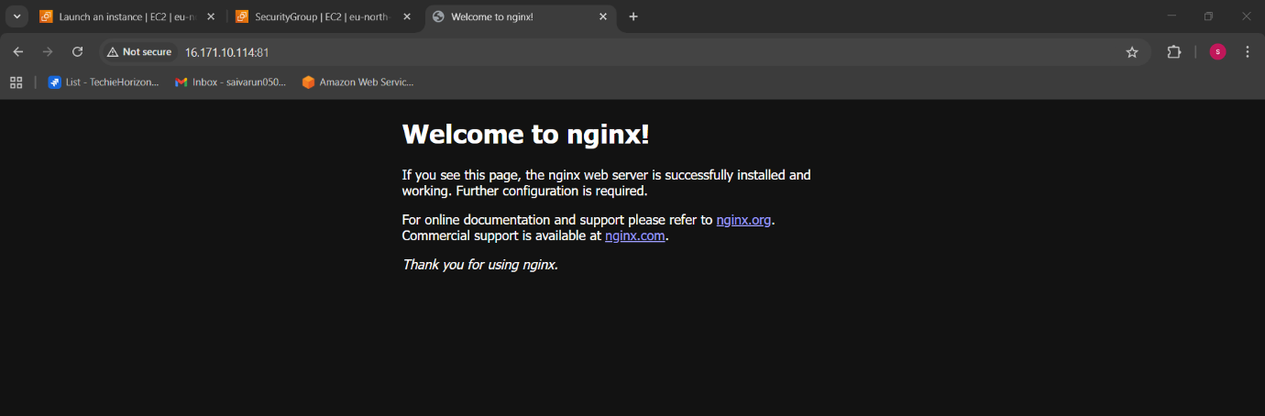

* Launch an instance and login to it through gitbash.
* Sudo su – to go to root
* Yum update -y
* Systemctl install nginx
* Systemctl status nginx
* Go to configuration file and edit the port number to 81 later save and exit from the file.
* Go to browser copy and paste the instance public ip:81 and hit enter.
* We get the above output stating that nginx is running in the specified port.

1. Deploy a sample index.html file on nginx.

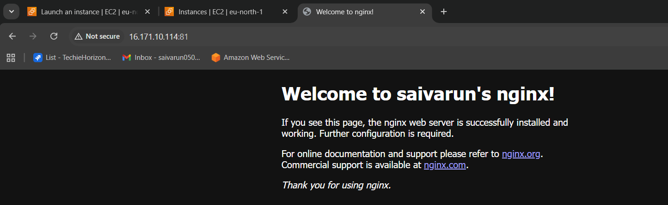

* Go to the html directory: cd/var/www/html/
* View the file :vi index.html
* And the html content in index.html
* Save and exit :wq!
* Restart the service systemctl restart nginx
* Go to browser and copy the ip address:81
* We can see the deployed html page in browser.

1. Install Apache and run Apache on port number 82

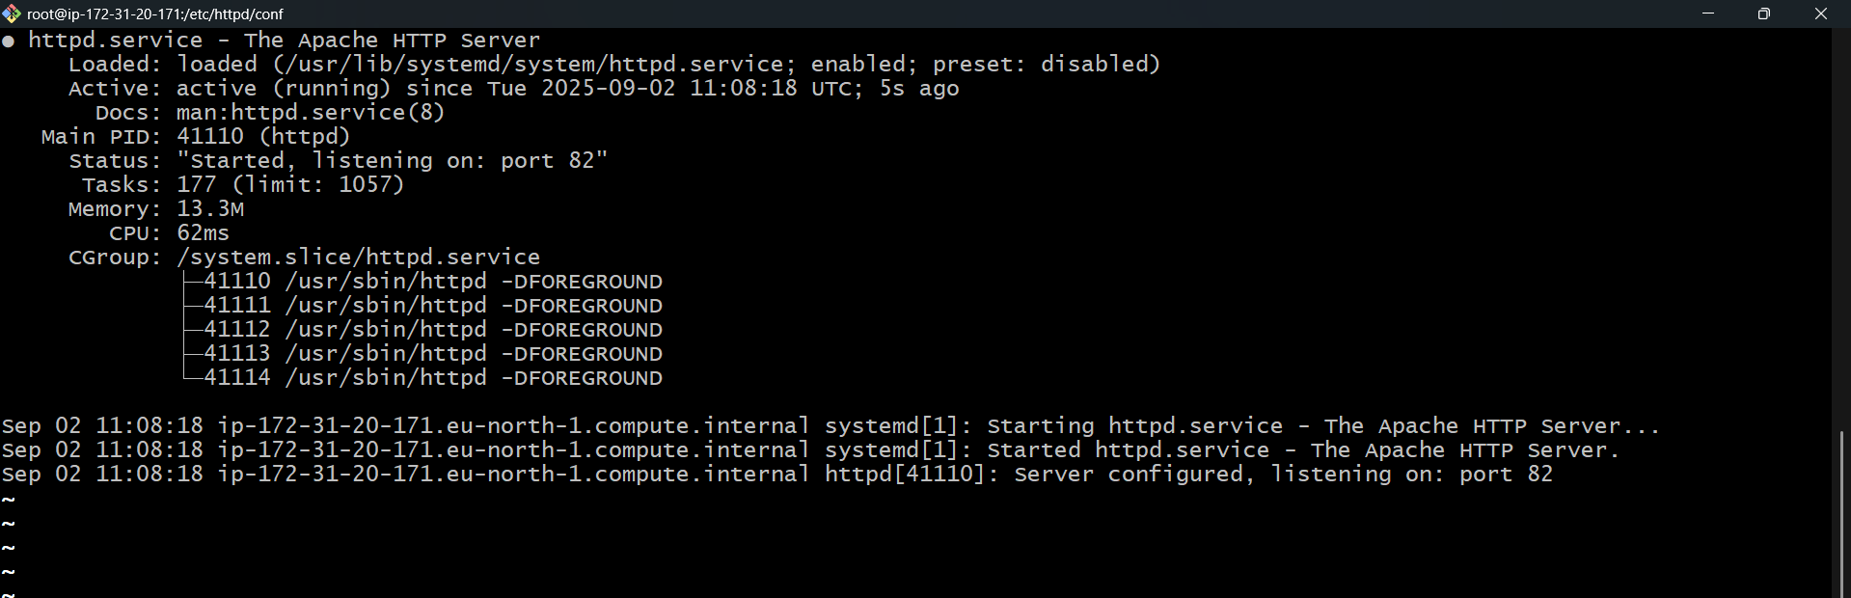

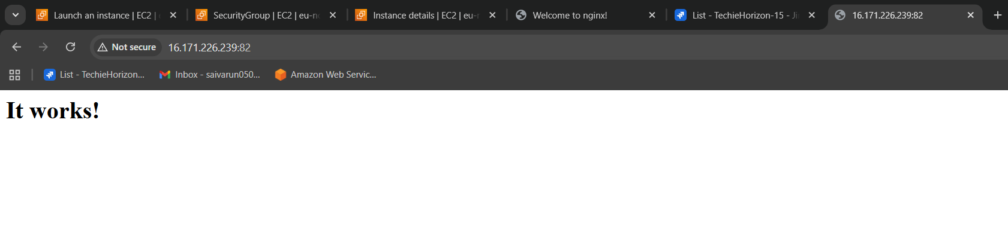

* Launch an ec2 instance in aws and edit the inbound rules to port82 and save.
* Login with key pair into gitbash terminal.
* Yum install httpd it is to install apache.
* Systemctl start httpd ,it is to start the apache.
* Systemctl status httpd, it is to check the status.
* Find / -name httpd.conf , it is to find the configuration file.
* Go to the path for configuration file by cd.
* To edit the port number we have to go to vi filename.conf.
* After entering change the listen 80 to 82, Then save and exit.
* Systemctl restart httpd.
* Copy the public ip of instance:82
* We can see the apache is running in the specified ip:82.

1. Deploy a sample index.html file on Apache.

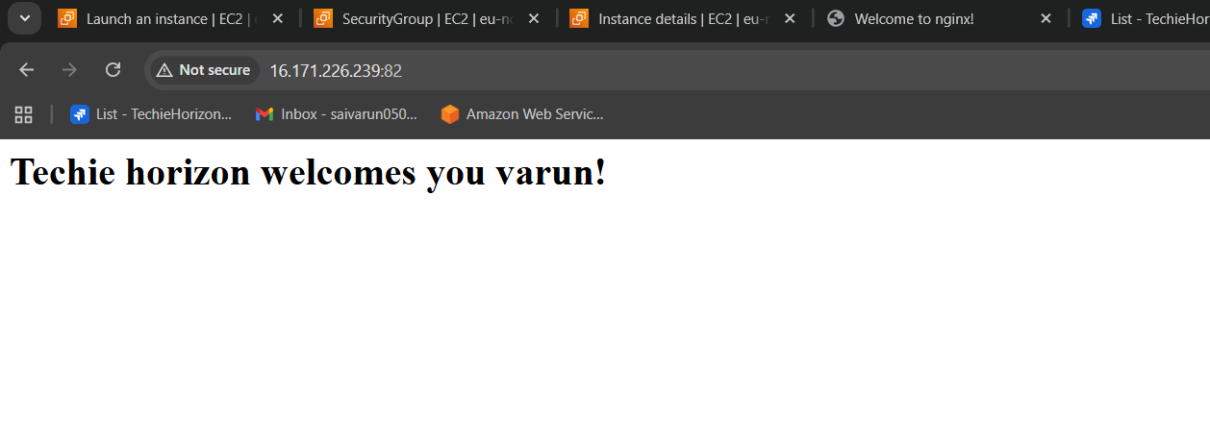

* Go to the html directory: cd/var/www/html/.
* View the file :vi index.html.
* And the html content in index.html.
* Save and exit :wq!.
* Restart the service systemctl restart httpd.
* Go to browser and copy the ip address:82.
* We can see the deployed html page in browser.

1. Install Apache tomcat on port number 8082

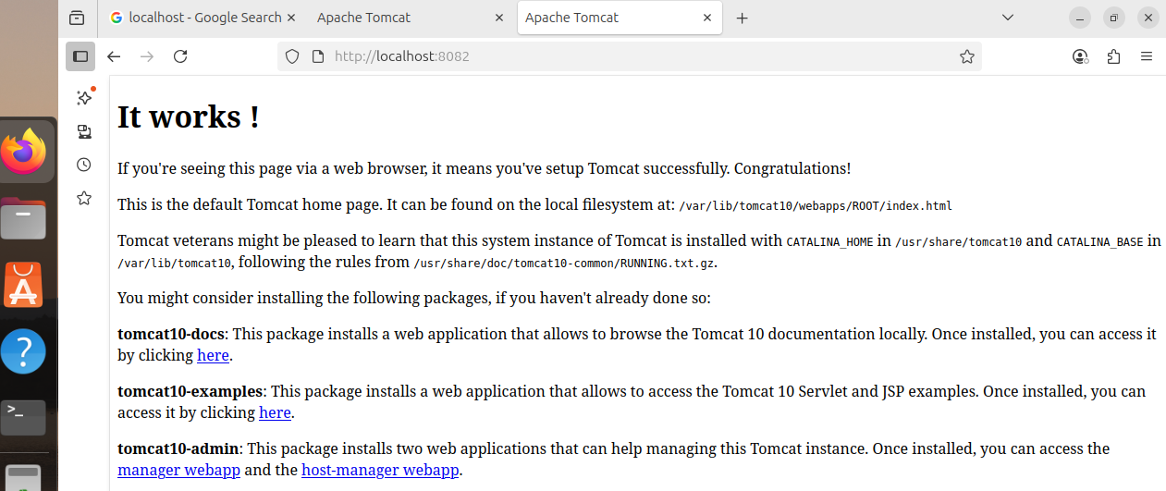

* Check the status using : netstat -na | grep 8080
* Ps -ef | grep 8080 - you see the port 8080 is listening.
* Default log files for tomcat is catlina.out you can see logs.
* Go to web page and enter : “ip “ :8080 – you can see tomcat apache is running on 8080 port
* Find the server.xml file
* Vi server .xml file
* Change the port to 8082 and save it
* Restart
* Check on browser ip address:8082

1. Deploy a sample app on webapps

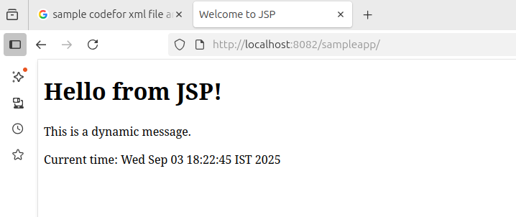

* Goto directory /opt/apache_tomat9/webapps
* Download the sample.war that is sample app file
* sample.war file in the directory .
* restart the service : systemctl restart tomcat 9
* Then go to web page an enter : ipadress:80/sample.
* Then you can see the sample app has been deployed.

1. Create a tomcat.service file for tomcat.

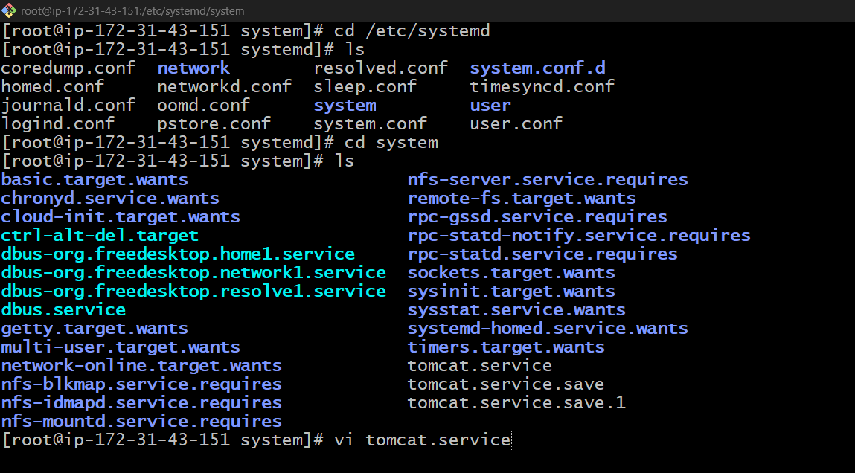

* Go to the default location of file that is system.
* Add tomcat.service file : vi tomcat.service
* Add configuration

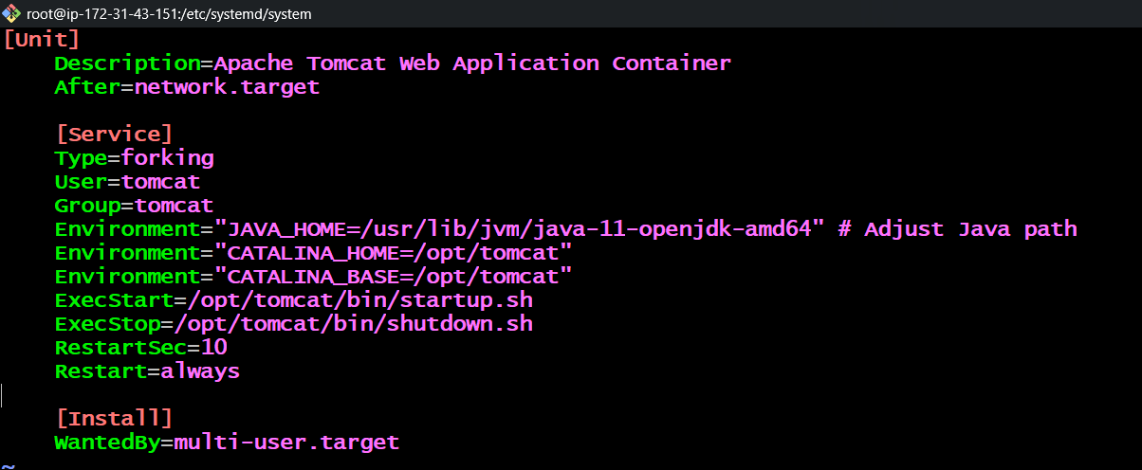

* save and exit
* •restart the service
* •make sure to create user with name tomcat and give access
* reload the daemon

1. Configure HA Proxy server

* I have crested 3 separate instances
* 1.nginx[13.60.167.77]
* 2.httpd [16.170.243.82]
* 3.haproxy[ 56.228.22.24]
* We have to install the following services in the following ip addresses
* We have to configure in the configuration file vi/etc/hosts and edit the port numbers
* Later on check on the browser so that the services are running after launching.
* now browse with HA-Proxy-Server PublicIP:80 it will distribute load to   
  Server-1, Server-2

